We are going to look at references:
- Relative references
- Absolute references
- Mixed references

- Open a new Excel spreadsheet
- Save this as Sales 2 in your ICT folder
- Type in the following text
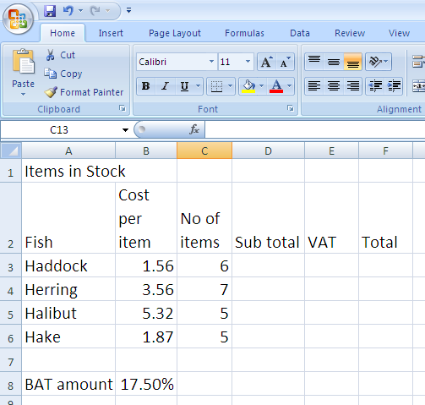

- Select headings A to F, double click a right border to best fit column widths
- Insert a formulae in D3 =B3*C3, copy this down to D6.
  - If you look at the formula that has copied, it has change to show the actual cell totals, this is called RELATIVE cell references.
- To find the VAT
  - In cell E3 type =D3*$B$8 and press enter
  - Copy this down to E6
  - Change the VAT amount to 20% see how they all change.
- In cell F3 type in the formula to add the sub total to the VAT and copy this down to F6
- Format figures B3-B6, D3to F6 to number with 2 decimal places
- Save, print and close

Summary of what we did
Relative D4 (formula change when copied)
Absolute $D$4 (formula unchanged when copied)

